

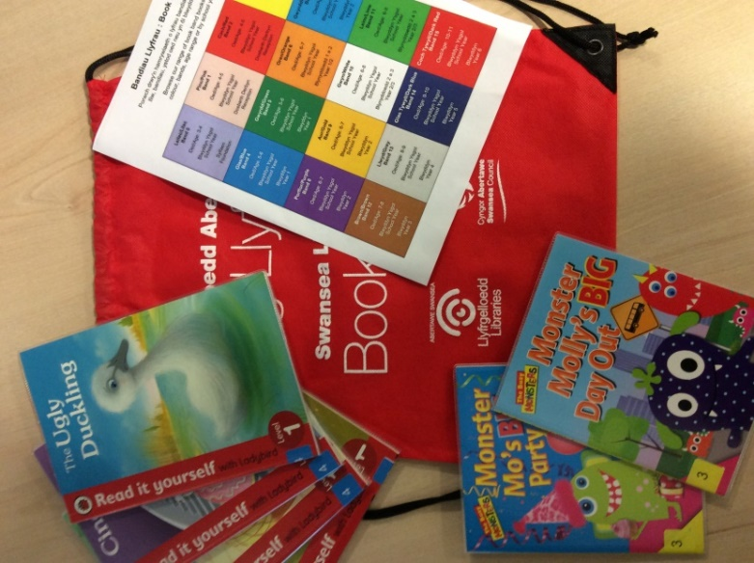

Opening times can be found at www.swansea.gov.uk/libraries or contact the library on 650953 to make an appointment.

Book Bags

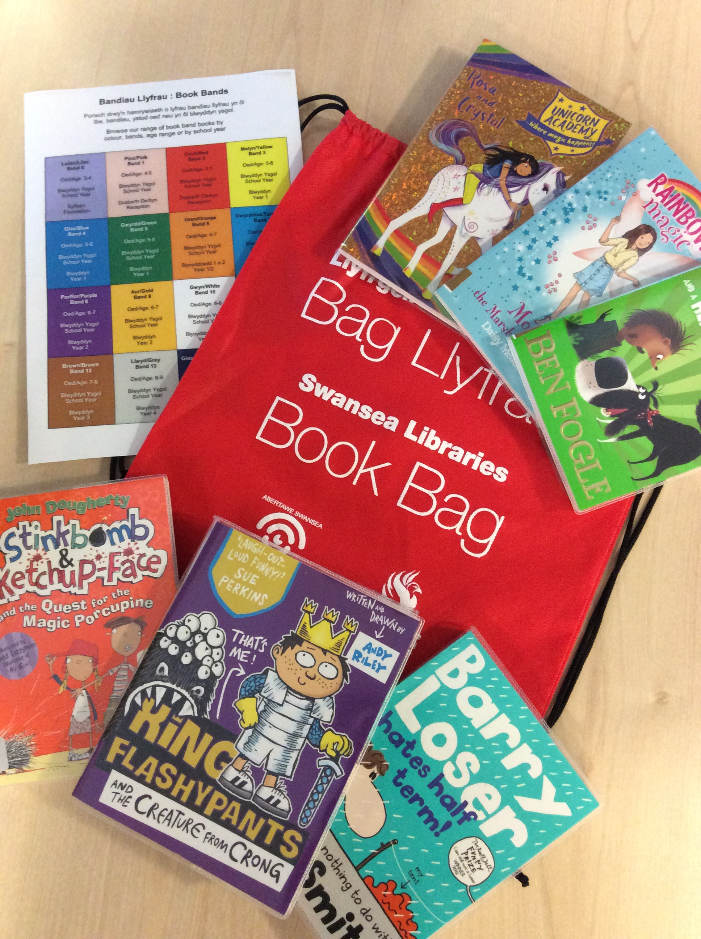
Brynhyfryd Library has a selection of new stock to help with your child's literacy.

Contact the library with your child's age/school year and we will arrange a time for you to collect a specially prepared bag of appropriate books to help with reading and literacy skills.

Available to borrow now at Brynhyfryd Library via our Click and Collect service.

